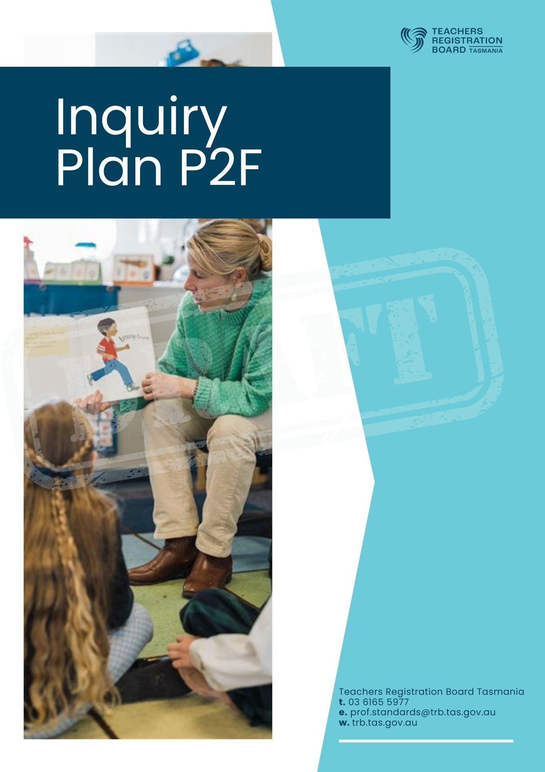

Inquiry Plan
PRT Name: |  | TRB Number:
School:

Inquiry Question

- Content and Context for Learning

1a The education setting context

My learning environment (demographics of the area, primary, secondary, early childhood, location, workplace educational priorities or philosophy)

1b The cohort of learners
My class / group of learners (composition, range of learning abilities)

1c The focus learners
My focus learners (literacy and numeracy levels, factors affecting learning, relevant personal information). What is the link between these learners and my Inquiry question?

1d Program of learning – content
What knowledge and skills am I trying to address in the Inquiry?

What curriculum am I using?

1e Targeted learning outcomes
The learning outcomes I want the learners to achieve.

What change(s) would I expect to see in my focus learners after the Inquiry?

- The Inquiry question, professional learning and professional responsibilities

2a The Inquiry question
Why and how did I choose my Inquiry question?

2b Professional learning
When I’ve observed the teaching practice of my Mentor or another fully registered teacher.

Date of observation:
Who was observed (name and TRB no):
What I saw / heard / experienced
What I learned
How this helps me address my Inquiry

2c. Professional Discussion

Date of conversation:
Who I met with (name and TRB no):
What was discussed and what I learned
How this helps me address my Inquiry

2d. Completion of Safeguarding Children and Young People mandatory reporting modules/ program

I declare that (full name of PRT) ______________________________has completed the schools Safeguarding Children and Young People mandatory reporting modules/ program and met their legal obligations as a teacher.

Mentor’s Signature: ___________________________________

Date:__________________________________________

- Apply knowledge to teaching practice through Inquiry Plan

Inquiry question

3a. Informing data
Assessment data, observations, learning plans, learner files, reports / factors affecting learning (e.g. medical reports) – remember to de-identify

3b. Professional Learning
Learning I will undertake to support the Inquiry

3c. Purpose of the Inquiry
Knowledge and skills I am trying to address in the Inquiry

3d. Inclusive practice
How I will cater for:
• Aboriginal and Torres Strait Islander learners
• learners who need extension
• learners with disability
• learners who need additional support to access the learning.

3e. Success criteria
Learning outcomes I want the learners to achieve

3f. Resources
What I will use to teach the Inquiry
3g. Strategies
What I will do to deliver the content and skills

3h. Activities
What the learners will be doing during the Inquiry

3i. Assessment
Assessment to be done during the Inquiry (allowing for a range of opportunities for learners to demonstrate their knowledge, including annotated learner work samples)

Formative | Summative

3j. Reflections
Prompts / questions to help guide reflection

- Implement the Inquiry Plan

4a Observations of practice
Based on a minimum of 3 visits by your Mentor or another fully registered teacher

Visit 1
Date of observation:
Who observed me (name and TRB no):
Summary of the feedback received and a reflection on what I have learned.

Visit 2
Date of observation:
Who observed me (name and TRB no):
Summary of the feedback received and a reflection on what I have learned.
Visit 3
Date of observation:
Who observed me (name and TRB no):
Summary of the feedback received and a reflection on what I have learned.

4b Gathering other evidence
The Inquiry should enable you to demonstrate proficiency across most of the seven standards. If you are uncertain after looking at your Evidence Map, then you can add more evidence (up to 10 items maximum) if required. Each item of evidence can be listed in Section 6 of this Inquiry Plan. This may include evidence from previous teaching experience as a provisionally registered teacher with your current group or a different group of learners. Your mentor / experienced colleague may have witnessed actions or practices you used that could demonstrate proficiency.

- Evaluate effectiveness of practice

Use these questions to guide you in reflecting on your Inquiry:

- Key findings and learnings.
- What effect did my inquiry have on my teaching practice? (How do I know?)
- What impact did my teaching have on student outcomes? (How do I know?)
- How will I develop my learning and teaching practice further?
- Can I share my learning with others?

- SUPPORTING EVIDENCE
The supporting evidence will be provided to your Workplace Panel.

This should be authentic evidence that was gathered during the Inquiry and may include:

- Observation templates
- work samples
- other assessments
- planning documents

- resources
- meeting notes
- correspondence with parents / carers
- photos, video or audio of learner work.

Please note: one piece of evidence should cover a range of standards – you do not need 37 separate pieces of evidence. You should discuss with your mentor whether the evidence you have included is sufficient to demonstrate proficiency. It is recommended to use a maximum of 10 pieces of evidence.

The supporting evidence should be briefly annotated to highlight the link between this piece of evidence and the standards the evidence is demonstrating.

List the supporting evidence used below:

Evidence 1
Evidence 2
Evidence 3
Evidence 4
Evidence 5
Evidence 6
Evidence 7
Evidence 8
Evidence 9
Evidence 10

6a. Evidence Map
 | DESCRIPTORS EVIDENCED | Which supporting piece of evidence from the Inquiry references this descriptor?
PROFESSIONAL KNOWLEDGE | Standard 1 – Know the students and how they learn
 | 1.1 Physical, social and intellectual development and characteristics of students
 | 1.2 Understand how students learn
 | 1.3 Students with diverse linguistic, cultural, religious and socioeconomic backgrounds
 | 1.4 Strategies for teaching Aboriginal and Torres Strait Islander students
 | 1.5 Differentiate teaching to meet the specific learning needs of students across the full range of abilities
 | 1.6 Strategies to support full participation of students with disability
 | Standard 2 – Know the content and how to teach it
 | 2.1 Content and teaching strategies of the teaching area
 | 2.2 Content selection and organisation
 | 2.3 Curriculum, assessment and reporting
 | 2.4 Understand and respect Aboriginal and Torres Strait Islander people to promote reconciliation between Indigenous and non-Indigenous Australians
 | 2.5 Literacy and numeracy strategies
 | 2.6 Information and Communication Technology (ICT)
PROFESSIONAL PRACTICE | Standard 3 – Plan for and implement effective teaching and learning
 | 3.1 Establish challenging learning goals
 | 3.2 Plan, structure and sequence learning programs
 | 3.3 Use teaching strategies
 | 3.4 Select and use resources
 | 3.5 Use effective classroom communication
 | 3.6 Evaluate and improve teaching programs
 | 3.7 Engage parents / carers in the educative process
 | Standard 4 – Create and maintain supportive and safe learning environments
 | 4.1 Support student participation
 | 4.2 Manage classroom activities
 | 4.3 Manage challenging behaviour
 | 4.4 Maintain student safety
 | 4.5 Use ICT safely, responsibly and ethically
 | Standard 5 – Assess, provide feedback and report on student learning
 | 5.1 Assess student learning
 | 5.2 Provide feedback to students on their learning
 | 5.3 Make consistent and comparable judgements
 | 5.4 Interpret student data
 | 5.5 Report on student achievement
PROFESSIONAL ENGAGEMENT | Standard 6 – Engage in professional learning
 | 6.1 Identify and plan professional learning needs
 | 6.2 Engage in professional learning and improve practice
 | 6.3 Engage with colleagues and improve practice
 | 6.4 Apply professional learning and improve student learning
 | Standard 7 – Engage professionally with colleagues, parents/carers and the community
 | 7.1 Meet professional ethics and responsibilities
 | 7.2 Comply with legislative, administrative and organisational requirements
 | 7.3 Engage with the parents/carers
 | 7.4 Engage with professional teaching networks and broader communities

Declarations
Please read the following information and then complete the Declarations.

Good Character and Fitness to Teach
As part of determining whether an applicant for full registration is of good character and fit to teach, sections 17J and 17K of the Teachers Registration Act 2000 requires the Board to consider any previous workplace disciplinary action, conviction or charge made against the teacher, as well as any medical, psychiatric, or psychological condition of the teacher, or competence of the person to teach.

A teacher should contact the Teachers Registration Board If they have any questions about these provisions and/or If they believe there may be an Issue In relation to their fitness to be a teacher, or their good character
Answer EVERY question by ticking the correct answer. | No | Yes
- Is your employer / principal aware of this injury / condition?  NOTE: If you have no medical conditions that currently impact on your ability to teach, please answer No. | ☐ | ☐
- Have you been medically assessed and deemed fit to work and undertake the duties of a teacher?  NOTE: If you have no medical conditions that currently impact on your ability to teach, please answer No. | ☐ | ☐
- Is there any other relevant information you would like to share about your condition or its management?  NOTE: If you have no medical conditions that currently impact on your ability to teach or you have no extra information to provide, please answer No. | ☐ | ☐
*If you have answered yes, please provide additional information here:
Click or tap here to enter text.
- I undertake to notify the Board within 28 days if my fitness to teach is impacted by a medical, psychiatric or psychological condition. | ☐ | ☐
- Have you ever been charged with and/or found guilty of a prescribed offence?  NOTE: A prescribed offence is an offence, committed in Tasmania or elsewhere, where a sentence of imprisonment may be imposed (whether or not it is imposed). (E.g., Driving under the influence, Common Assault, Stealing, Drug offences, Public Nuisance). | ☐ | ☐
*If you have answered yes, please provide details here:
Click or tap here to enter text.
- I understand that I must notify the Board within 28 days if I am charged with and/or found guilty of a prescribed offence in Tasmania, or anywhere else. | ☐ | ☐
- Are you currently residing in a country other than Australia? | ☐ | ☐
*If you have answered yes, please state the country and how long you have lived there.:
Click or tap here to enter text.
Answer EVERY question by ticking the correct answer. | No | Yes
- Have you, as an adult (over 18 years of age), ever resided outside of Australia for a period of twelve or more continuous months?  NOTE: If you answer Yes to this question, you must provide countries and years. | ☐ | ☐
*If you have answered yes, please state the country or countries and the years you lived in each:
Click or tap here to enter text.
- I hereby consent to a check of the records of Tasmania Police and other Australian police jurisdictions and to the release of police records recorded against my name by the Tasmania Police to the Executive Officer, Teachers Registration Board of Tasmania.  NOTE: Without your consent we cannot process your application | ☐ | ☐
- In consideration of Tasmania Police releasing police records, I hereby indemnify the services of the CrimTrac Agency, other police jurisdictions and the State of Tasmania, its servants and agents including all members of the Department of Police and Emergency Management, against all actions, suits, proceedings, causes of action, costs, claims and demands whatsoever that may be brought or made against it or them by anybody or person by reason of, or arising out of, the release of police records recorded against my name or purporting to either relate to or concern me.  NOTE: Without indemnifying CrimTrac we cannot process your application | ☐ | ☐
- As a teaching professional in Tasmania, I have read the TRB's Code of Professional Ethics, the Australian Professional Standards for Teachers and the TRB's Professional Boundaries - Guidelines for Tasmanian Teachers, and I understand that it is an expectation that I abide by these professional codes, standards and guidelines. | ☐ | ☐
- I authorise that the Teachers Registration Board of Tasmania may make enquiries of, and exchange information with, any corresponding registration authority or any other person, employer, government department or government body that the Board considers may have information relevant to the determination of my application.  Note: If you answer no we cannot process your application | ☐ | ☐

International residency
I have resided outside of Australia, as an adult, for a period of more than 12 months, in the countries listed below:
Country: | Month/Year from: | Month/Year to:
Click or tap here to enter text. | Click or tap here to enter text. | Click or tap here to enter text.
Click or tap here to enter text. | Click or tap here to enter text. | Click or tap here to enter text.

Applicant Declarations
Please ensure that you answer EVERY question.

Answer EVERY question by ticking the correct answer. | No | Yes
- Have you ever had your registration or any other entitlement to teach cancelled, suspended or withdrawn in Australia or in any other country? | ☐ | ☐
- Have you ever been refused registration or any other entitlement to teach in Australia or in any other country? | ☐ | ☐
- Have you ever been dismissed or asked to resign or retire from a teaching position in Australia or in any other country? | ☐ | ☐
- Have you ever been (or are you currently) the subject of disciplinary proceedings (or any action that might lead to such proceedings) in relation to your employment in Australia or in any other country? | ☐ | ☐
- Are you currently, or have you been within the last five years, subject to a performance management process (or similar) as a result of under-performance? | ☐ | ☐
- Have you experienced and/or suffered any medical, psychiatric or psychological conditions that CURRENTLY IMPACT on your ability to undertake the duties of a teacher? | ☐ | ☐
*If you have answered yes, please describe the nature and impact of your condition and how it is being managed:
Click or tap here to enter text.

Your Declaration

I declare that the information I have provided in this application and the information contained in any documents accompanying this application are true and correct to the best of my knowledge and belief.
I have presented the required evidence of my proficient professional knowledge, practice and engagement against the 7 Teacher Standards in line with the TRB process and policy to my approved Workplace Panel.
I understand that all material related to this process must be retained at the school and by myself for 12 months and available for audit by the office of the TRB, if requested.

Full Name: | Click or tap here to enter text.
Signature: |  | Date: | Click or tap to enter a date.

Get in touch:

For more information, or assistance contact the TRB Professional Standards Team or visit our
website:

prof.standards@trb.tas.gov.au
(03) 6165 5977
https://www.trb.tas.gov.au/

